MC Unit Redemption

- Purpose

As soon as the customer was able to settle his account, he may now go to the branch to redeem his previously deposited motorcycle for Unit Redemption.

- Views
  - List View
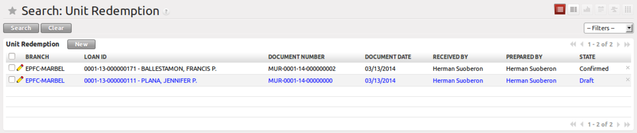
Figure 1. List view of Unit Redemption

  - Form View
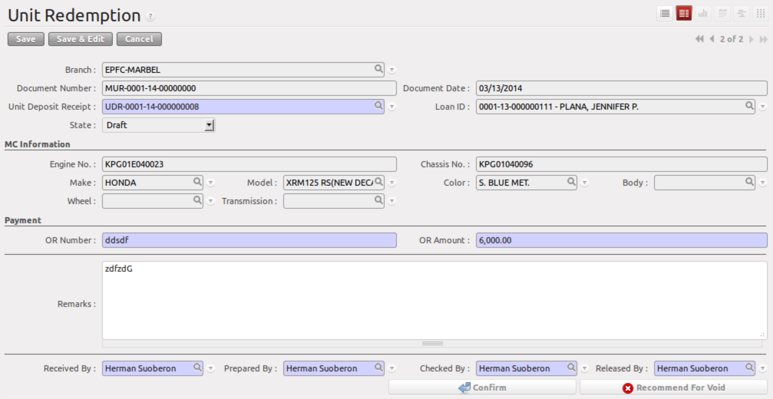
Figure 2. Form view of Unit Redemption

- Menu and Access Rights
  - Menu – Loan > MC Deposit > Unit Redemption
  - Access Rights
Role | Read | Write | Create | Delete
Receptionist | Yes | Yes | Yes | No
CI/Collector | Yes | Yes | Yes | No
Branch Manager | Yes | Yes | No | No

- Required Fields
All required fields can be easily distinguished from the form view. These are the fields highlighted in Figure 2.

- UDR # – unit deposit receipt document
- OR Number – Official Receipt number
- OR Amount – amount settled by the customer
- Received By –
- Prepared By –
- Checked By –
- Released By –

- Workflow
Below is the list of states and visibility of the various buttons based on the record state:

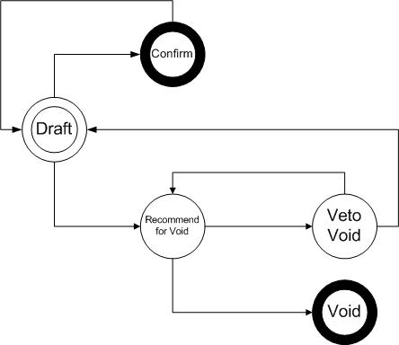
Figure 3. Workflow of Unit Redemption

State | Description | Visible Buttons
Draft | Initial state of the record | Confirm  Recommend for Void
Confirm | Confirms the record | Set Back to Draft*
Draft/Confirm - Recommend | Redemption slip was recommended for void by the accounting assistant | Veto Void Recommendation  Void
Void | Cancels the record | N/A
Veto Void Recommendation | Cancels Recommendation for Void | Recommend for Void  Confirm  Set Back to Draft
* for finalization

- User Action
Below is the list of user action available for specific users and its corresponding procedures:

Button | Action | Triggred By
Confirm | - Creates product information found in Warehouse > MC Units > Deposited Units  - Creates a draft record in Asset Transfer Slip | Receptionist  CI/Collector  Branch Manager
Recommend for Void | No Action | Accounting Assistant
Void | - Deletes product information found in Warehouse > MC Units > Deposited Units  - Voids the draft record in Asset Transfer Slip | Branch Manager
Veto Void Recommendation | No Action | Accounting Assistant
Set Back to Draft | Only allow this action when Asset Transfer Slip is still in ‘Draft’ state | Accounting Assistant  Accounting Assistant 2  Branch Manager

- Field Visibility
All fields are visible in all states.

- Reports and Print Outs
